


DEPARTMENT OF MATHEMATICS

Contribution of Indian Mathematician to the World of Mathematics
Date: 17 December 2025

1 | Date | 17 DECEMBER 2025
2 | Conducted through DRC/JKC/ELF/Dept.etc | Department of Mathematics
3 | Nature of Activity | Essay Writing Activity
4 | Title of Activity | Essay Writing competition on Contribution of Indian Mathematicians to the World of Mathematics
5 | Name of the Department / Committee | Department of Mathematics
6 | Details of Resource person | Smt.A.Padmavathi, Lecturer in Physics and Faculty of Department of Mathematics
7 | No.of students participated | 11
8 | Activity outcomes: | - Knowledge of mathematical history  - Improved essay writing skills  - Enhanced confidence and creativity  - Awareness of India’s global contributions
9 | Name of the lecturer who planned and conducted the activity | Department of Mathematics
10 | Signature of the In-charge | 
11 | Signature of the Principal | 

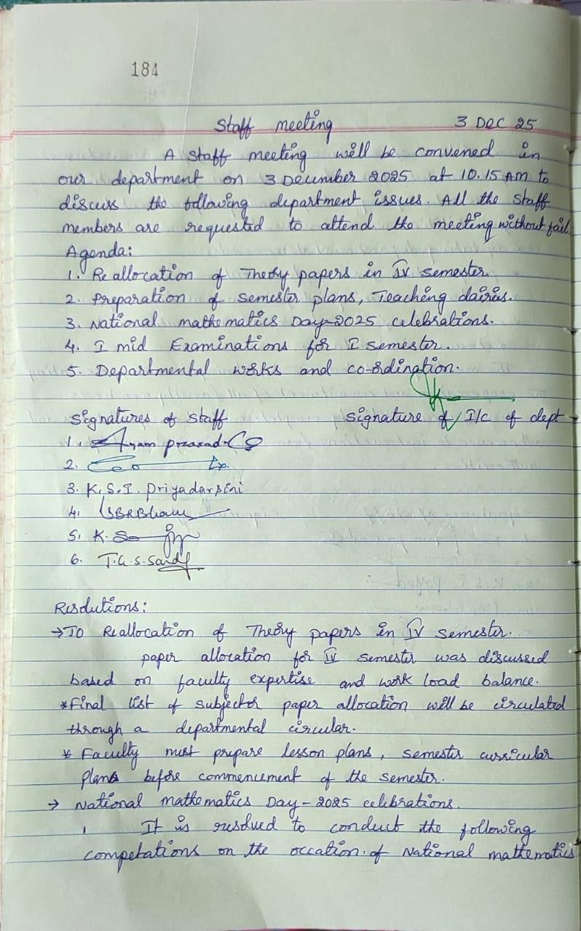
Department Minutes and Resolutions

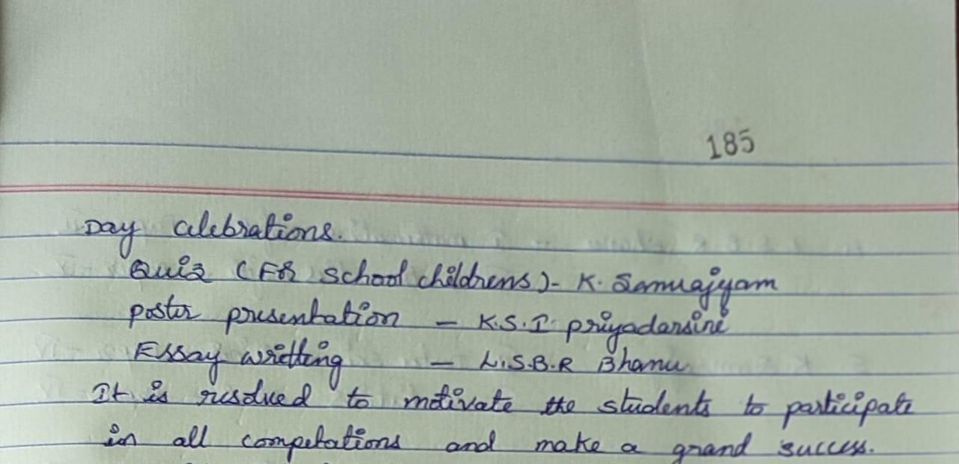
Principal Permission Letter
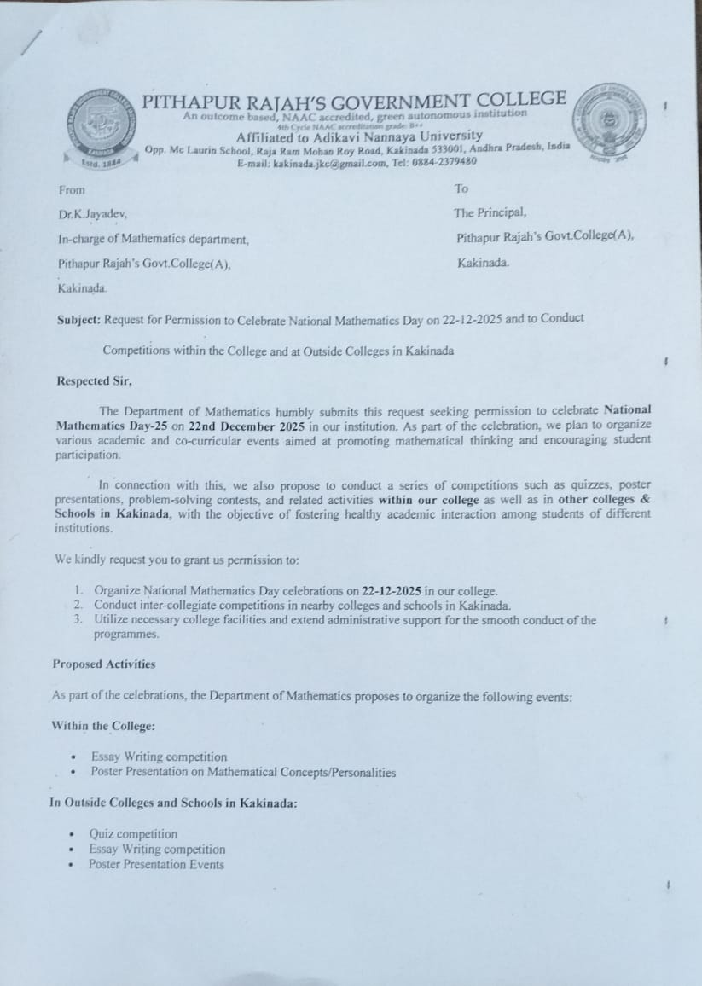

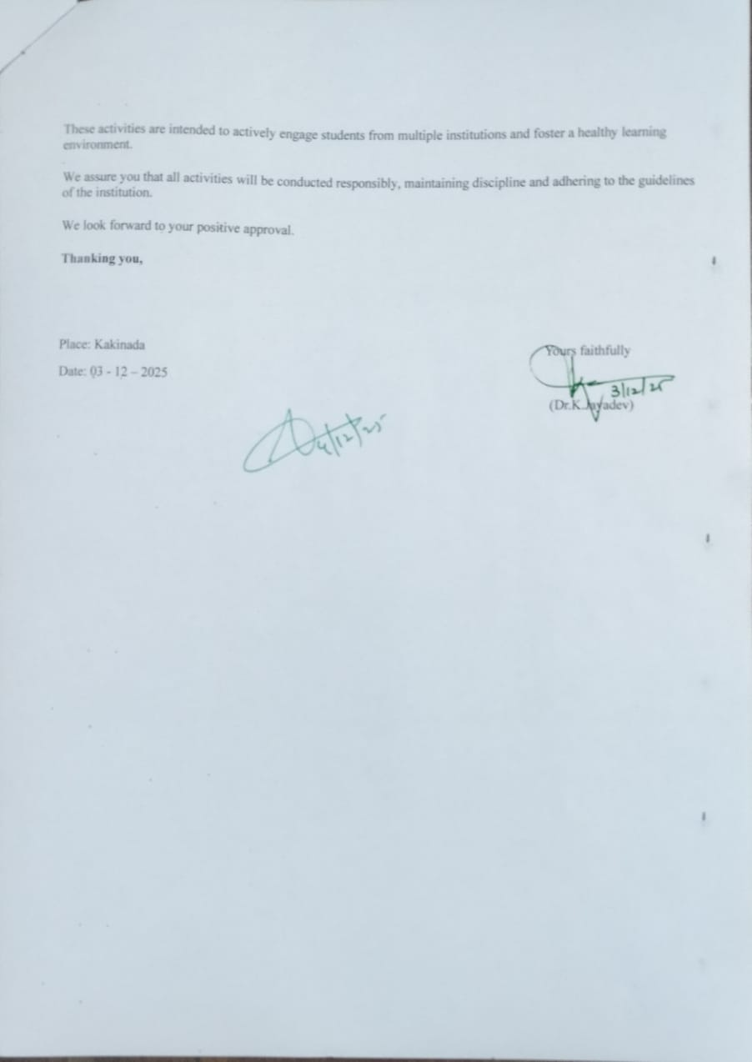

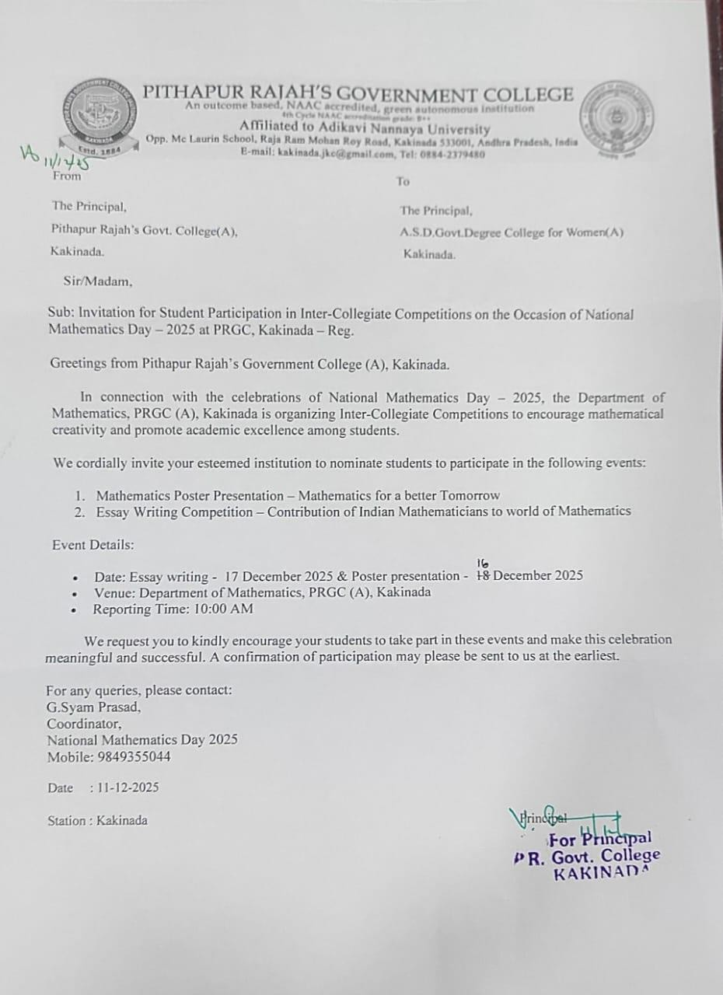
Invitation for students of A.S.D.Govt.Degree College for Women(A)

Invitation for students of Ideal College of Science & Arts(A)
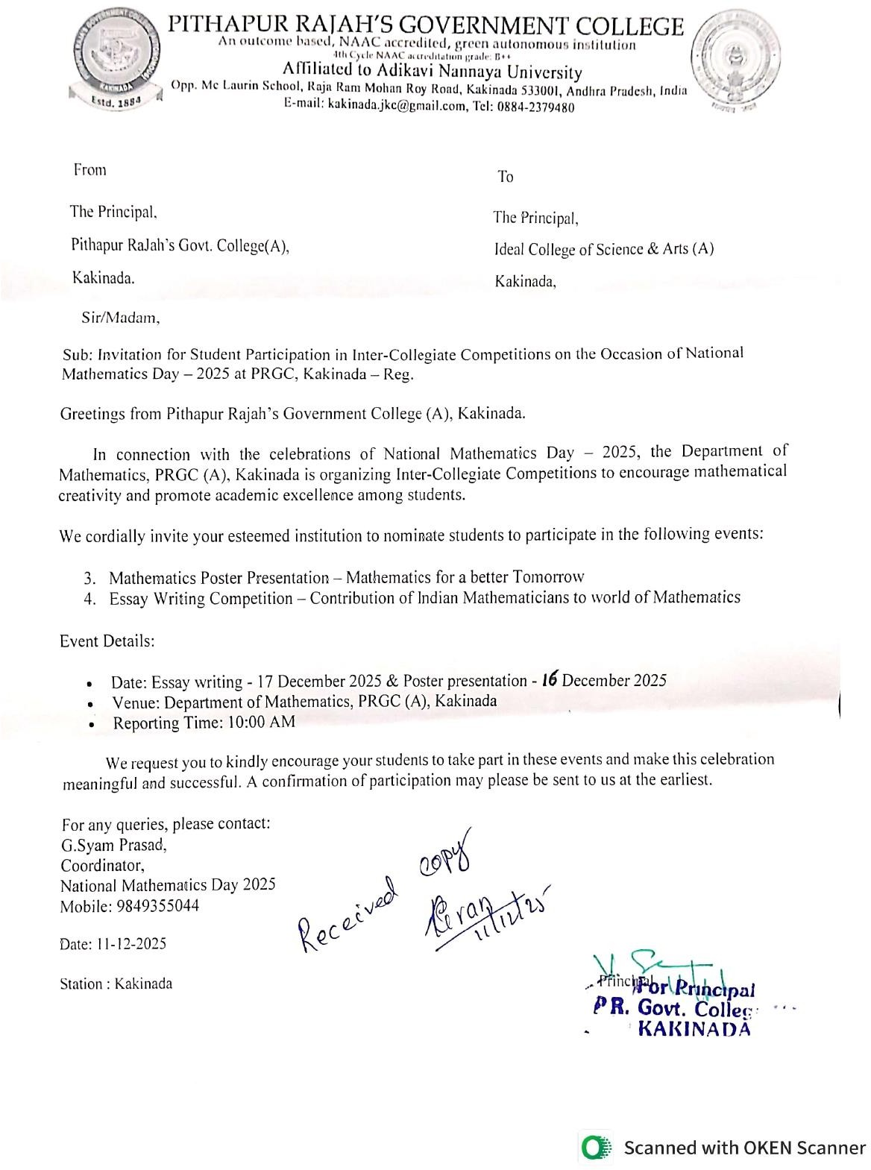
STUDENTS NOTICE


DEPARTMENT OF MATHEMATICS
NOTICE
The Department of Mathematics is delighted to announce that, on the occasion of National Mathematics Day, a series of academic and creative events will be conducted to honor the legacy of mathematical brilliance and inspire students to appreciate the importance of mathematics in everyday life.
To mark this special day, the following competitions will be organized:

1. Mathematics Poster Presentation
Theme: Mathematics for a Better Tomorrow
Students are invited to design visually appealing and conceptually strong posters showcasing the role of mathematics in shaping a progressive, scientific, and technologically advanced future. Posters may highlight concepts, innovations, real-life applications, or futuristic ideas influenced by mathematical thinking.

2. Essay Writing Competition
Topic: Contribution of Indian Mathematicians to the World of Mathematics
Participants are encouraged to write thoughtful and well-structured essays exploring the invaluable contributions of Indian mathematicians—from ancient to modern times—who have enriched the global mathematical landscape. Essays may include historical insights, noteworthy discoveries, and the lasting influence of Indian mathematical traditions.

Event Details:
- Date: Poster Presentation: 16-12-2025 & Essay Writing Competition: 17-12-2025
- Time: 11.00 AM
- Venue: At Mathematics Department – Ramanujan Lecture Hall
- Participant Eligibility: Open to all interested students
- Registration Process: Submit your names to the Mathematics Department or the respective class coordinators on or before 15-12-2025
- Judging Criteria: Creativity, originality, clarity of presentation, and relevance to the theme
- Awards: Winners will receive certificates and attractive prizes.

Note:

Students are encouraged to participate whole-heartedly and make this celebration meaningful. Let us honor the spirit of National Mathematics Day by recognizing the importance of mathematics in shaping knowledge, innovation, and the future of our nation.
— Department of Mathematics
Signature of the I/C of the Dept.

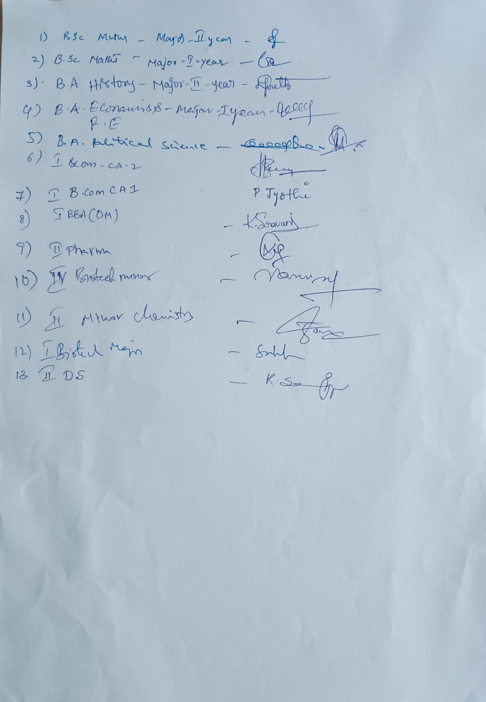

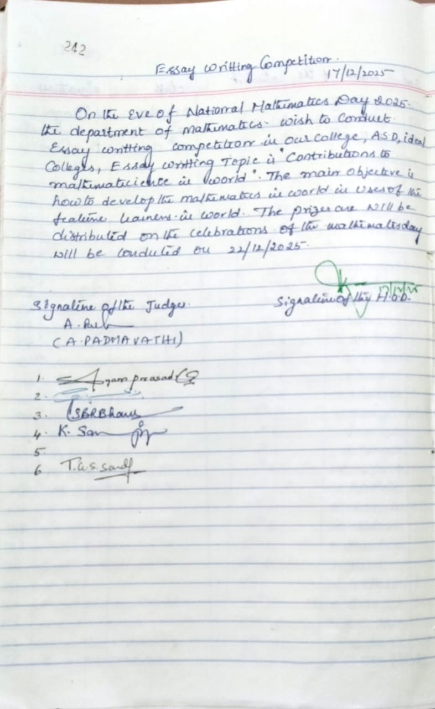
Activity Register file

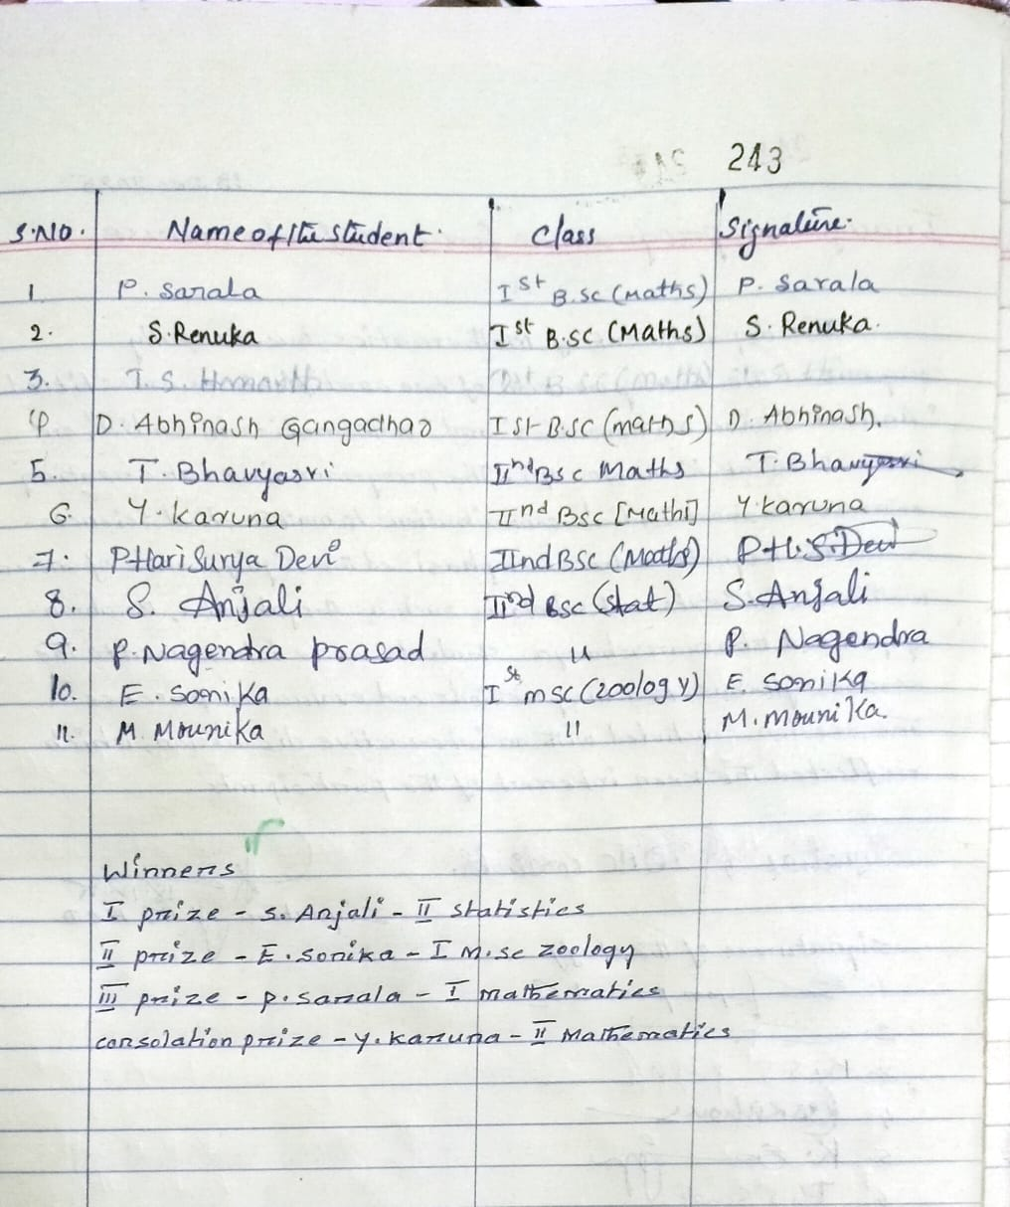

WINNERS:
- 1St PRIZE – S. ANJALI – II STATISTICS MAJOR
- 2nd PRIZE - E. SONIKA – I M.SC ZOOLOGY

- 3rd PRIZE – P. SARALA – I B.SC MATHEMATICS MAJOR

- CONSOLATION PRIZE - Y. KARUNA – II B.SC MATHEMATICS MAJOR

ESSAY WRITING COMPETITION

Contribution of Indian Mathematician to the World of Mathematics

Aim of the Activity
The aim of this activity is to encourage students to explore and understand the significant contributions of Indian mathematicians and recognize their impact on the development of world mathematics.

Introduction
India has been a pioneer in the field of mathematics since ancient times. Indian mathematicians introduced many important concepts that are widely used today. Their contributions laid the foundation for modern mathematics and science. This activity aims to highlight their achievements and inspire students to value India’s rich intellectual tradition.

Objectives
- To promote awareness of Indian mathematicians
- To improve research and essay writing skills
- To encourage critical and logical thinking
- To instill pride in India’s scientific achievements

Guidelines
- The essay must be written neatly.
- Word limit: 300–500 words.
- Content should be relevant and original.
- Proper grammar and spelling must be used.
- The decision of judges is final.

Activity Description
On 17 December 2025, students participated actively in the Essay Writing Competition. The classroom environment was calm and focused. Students showcased their creativity, knowledge, and writing skills through well-structured essays.

Contribution of Indian Mathematicians to the World of Mathematics
India has made remarkable contributions to mathematics since ancient times. One of the greatest contributions of Indian mathematicians is the invention of zero and the decimal number system, which revolutionized mathematical calculations worldwide.
Aryabhata was one of the earliest Indian mathematicians who calculated the approximate value of pi and explained the concept of place value. Brahmagupta introduced rules for zero and negative numbers, which became the foundation of algebra. Bhaskara II contributed significantly to algebra and early concepts of calculus.
Madhava of Sangamagrama developed infinite series for trigonometric functions, much before similar discoveries in Europe. In modern times, Srinivasa Ramanujan amazed the world with his extraordinary work in number theory and mathematical formulas.
The contributions of Indian mathematicians continue to influence modern science, engineering, and technology. Their work proves that India has always been a land of knowledge and innovation.

Indian Mathematicians – Summary Table
Mathematician | Contribution
Aryabhata | Value of π, place value
Brahmagupta | Zero, negative numbers
Bhaskara II | Algebra, calculus
Madhava | Infinite series
Ramanujan | Number theory

Learning Outcomes
- Knowledge of mathematical history
- Improved essay writing skills
- Enhanced confidence and creativity
- Awareness of India’s global contributions

Conclusion
The Essay Writing Competition was informative and meaningful. It encouraged students to appreciate the achievements of Indian mathematicians and take pride in India’s contribution to world knowledge.

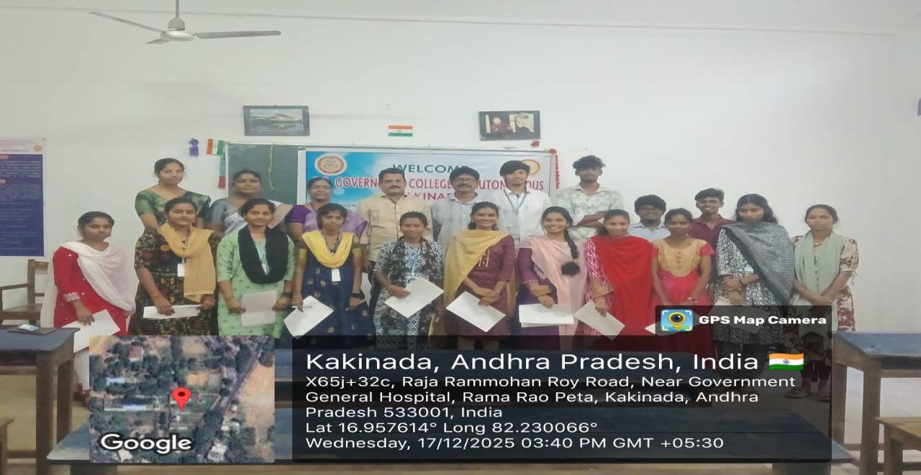
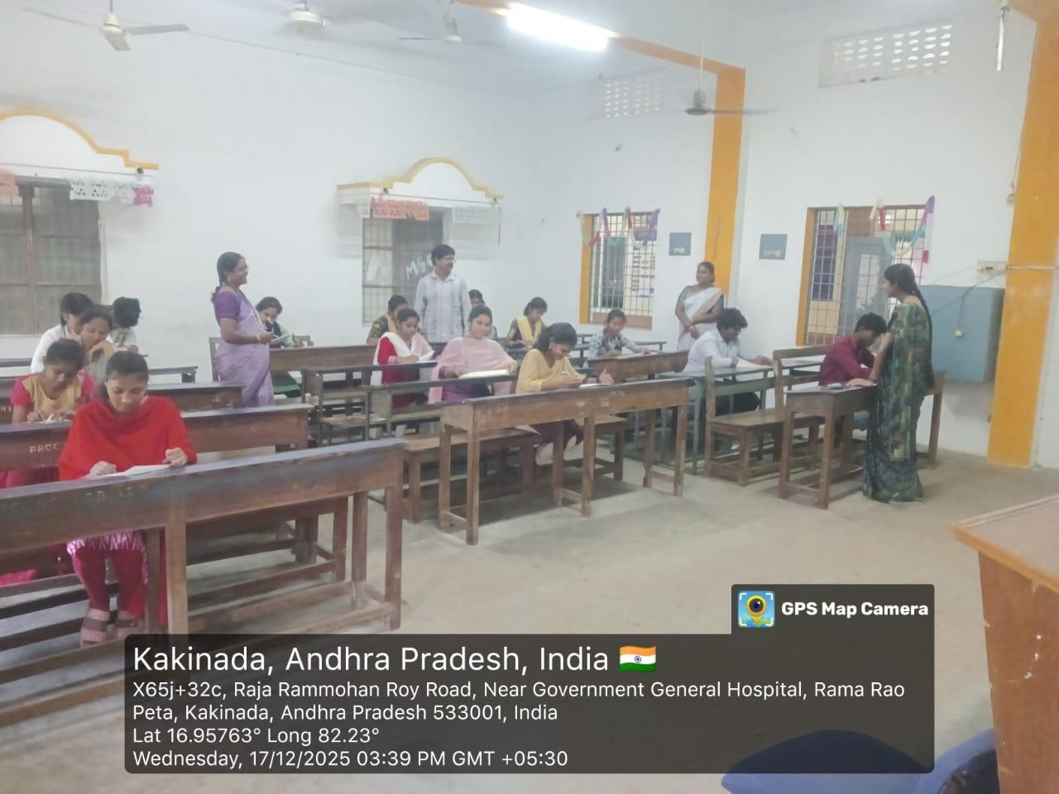
Photo Gallery
